**Final Capstone Project: Retail Stream**

Stage 1:

Push sales data set from local to s3 bucket using python

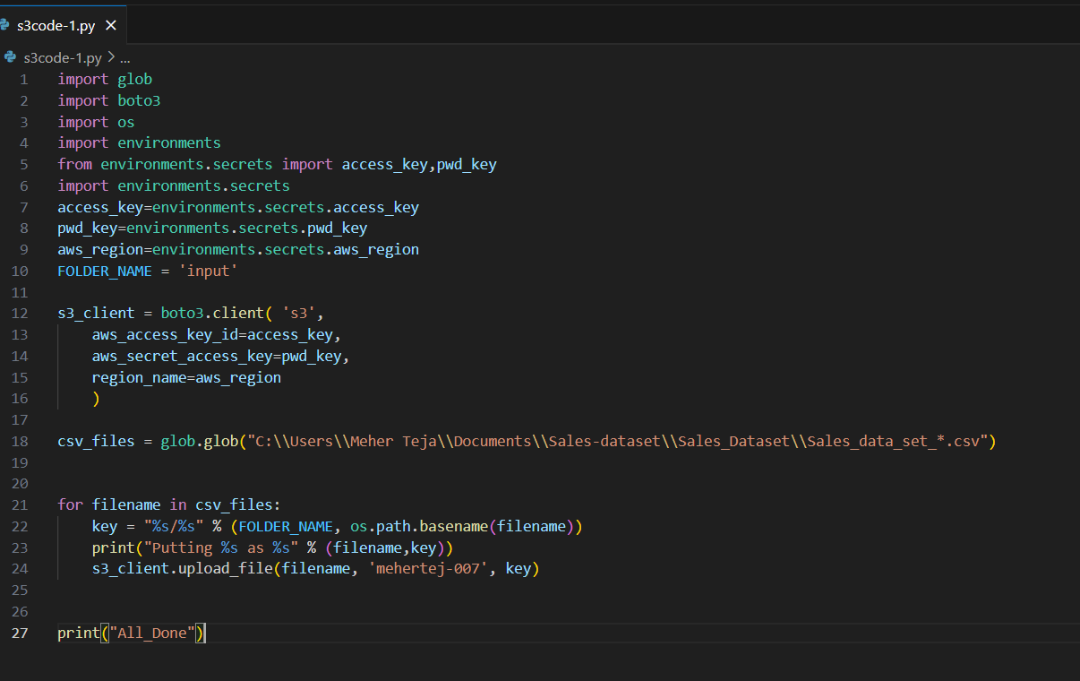

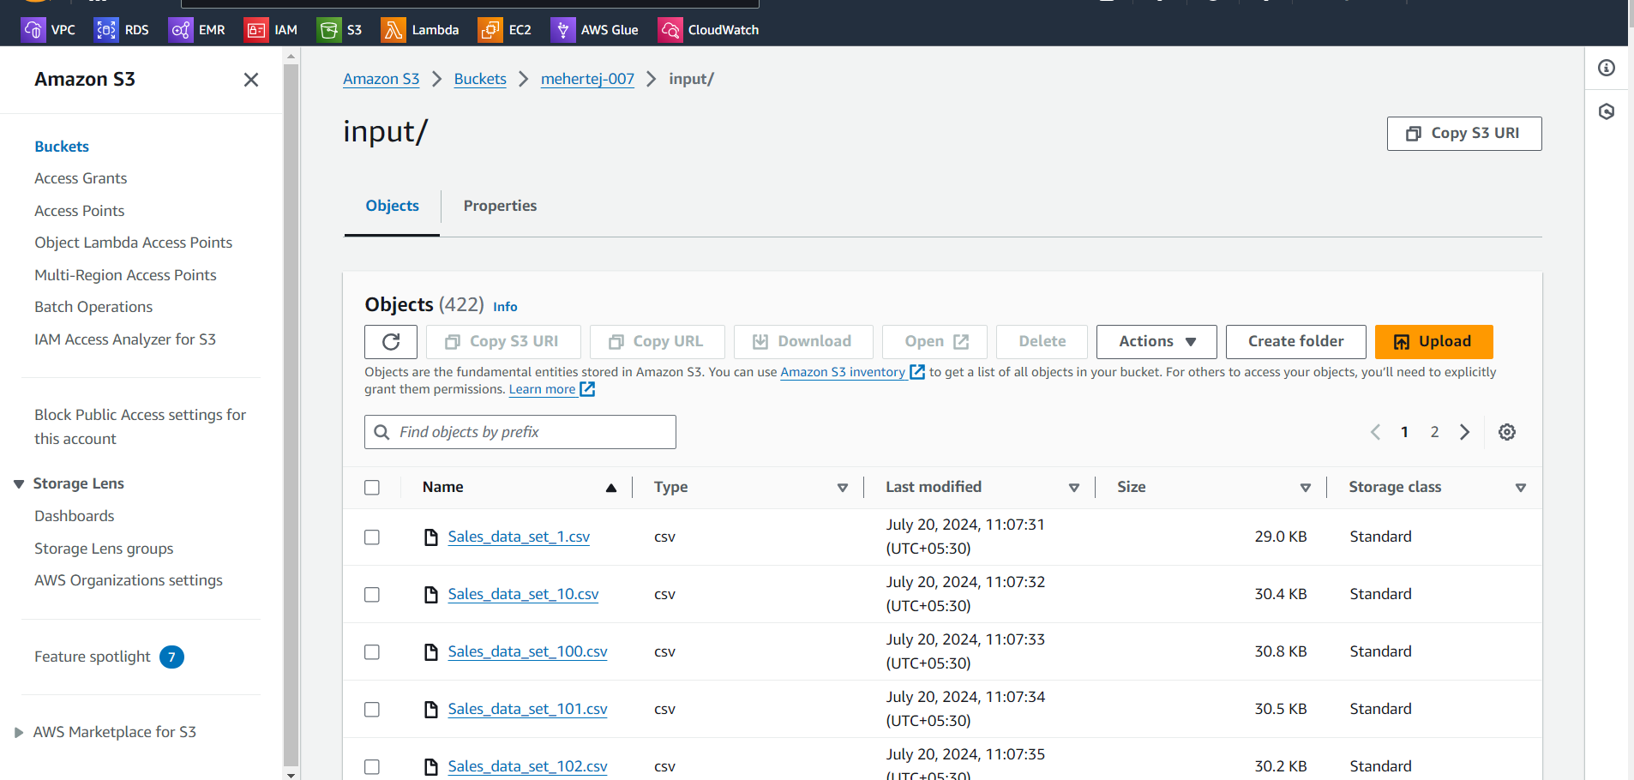

once data is available in S3 , do data cleaning and merge all files in S3 in another bucket (new bucket) using Glue with schedule

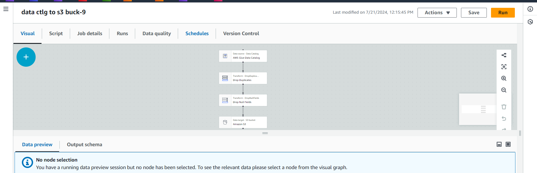

Schedule interval: 5 minutes

And store to mysql rds using aws lambda python

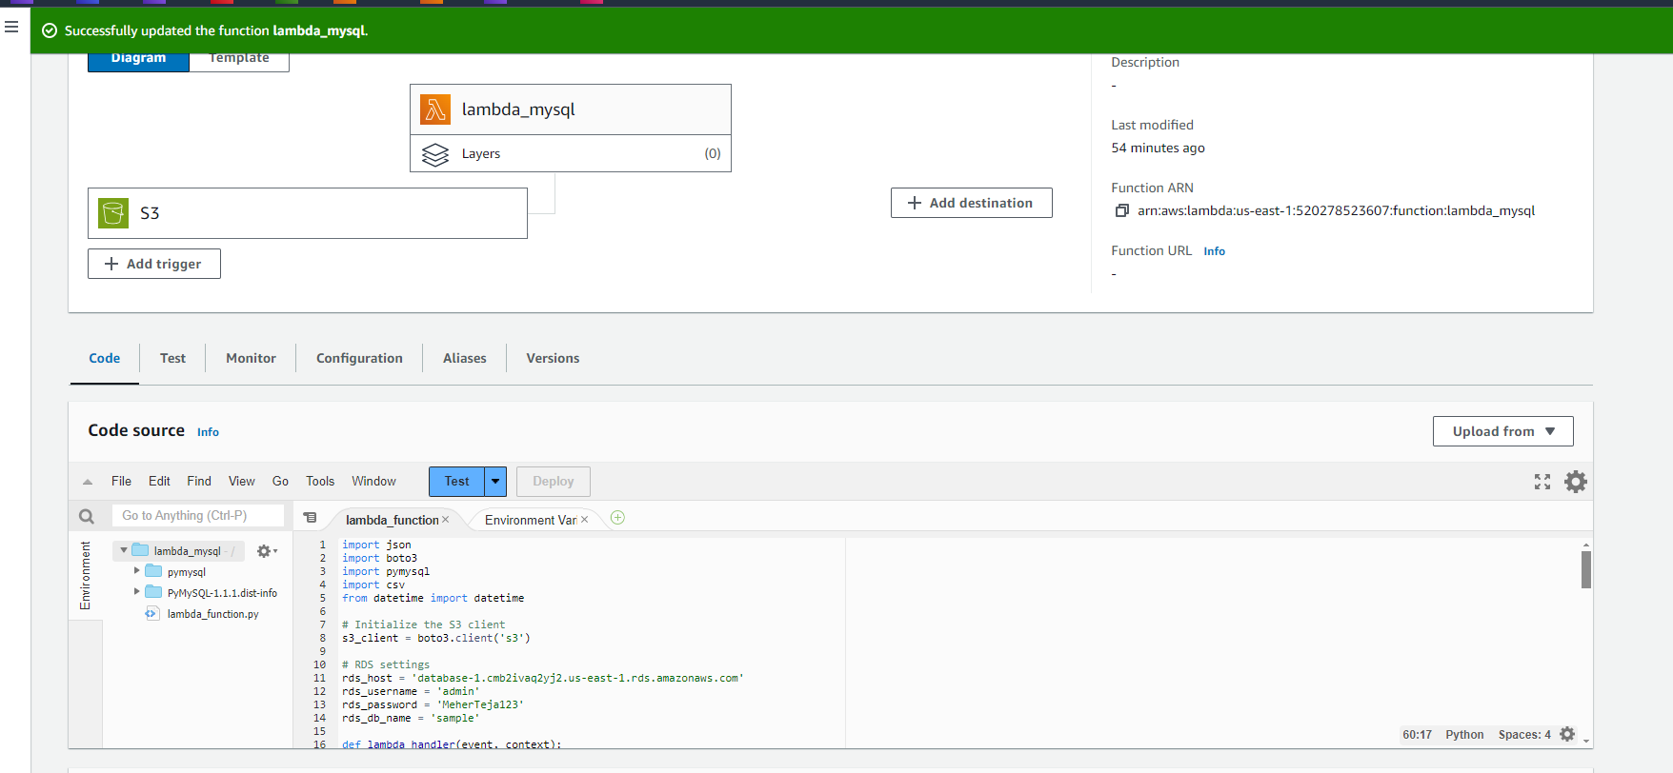

Cloudwatch logs:

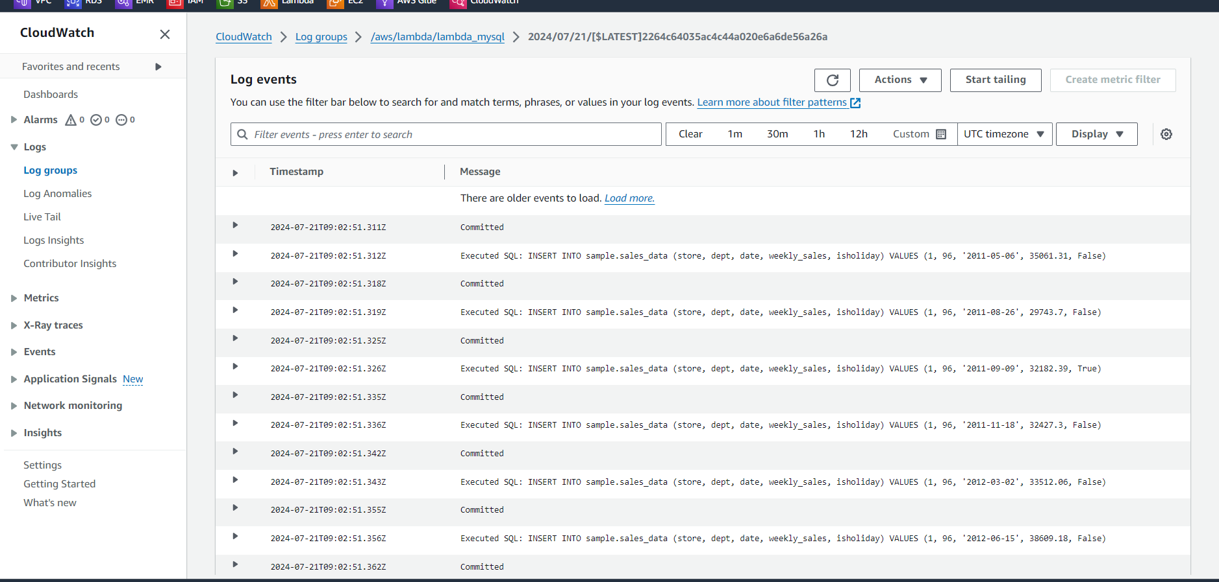

Verify the data in aws rds mysql

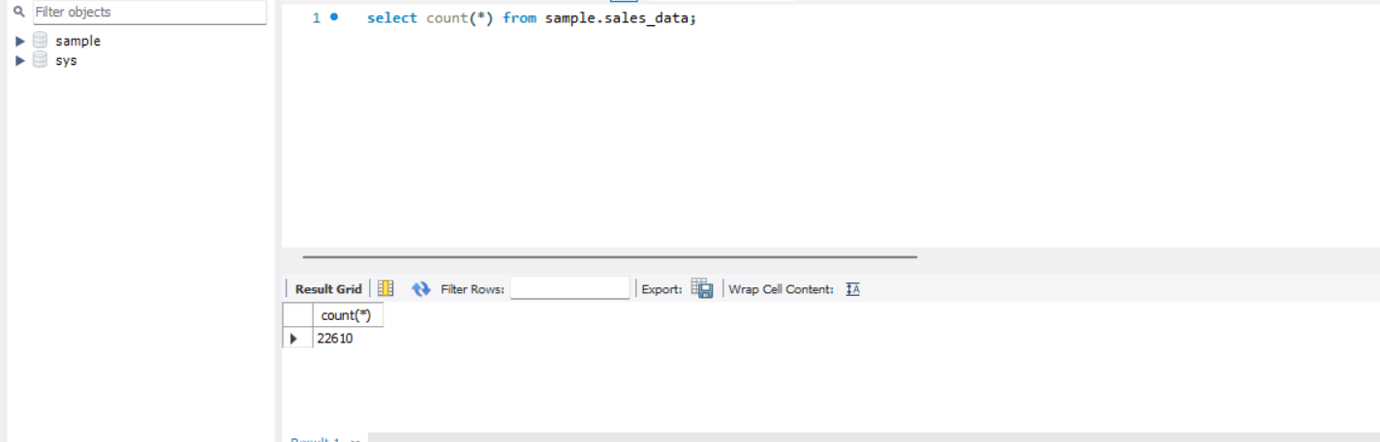

Stage 2:

1. Pass all feature files and store it in HDFS

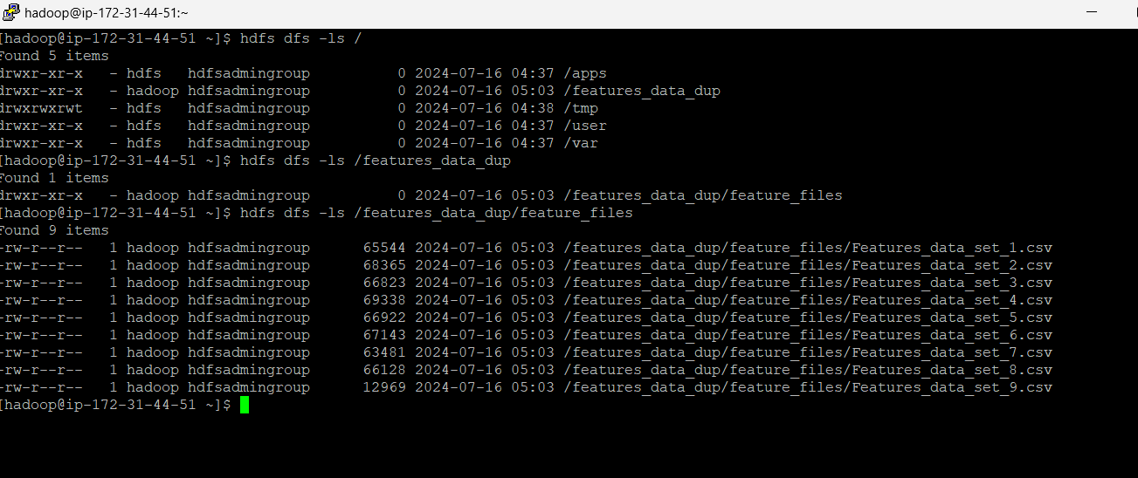

1. Pushing data from hdfs to hive using pyspark

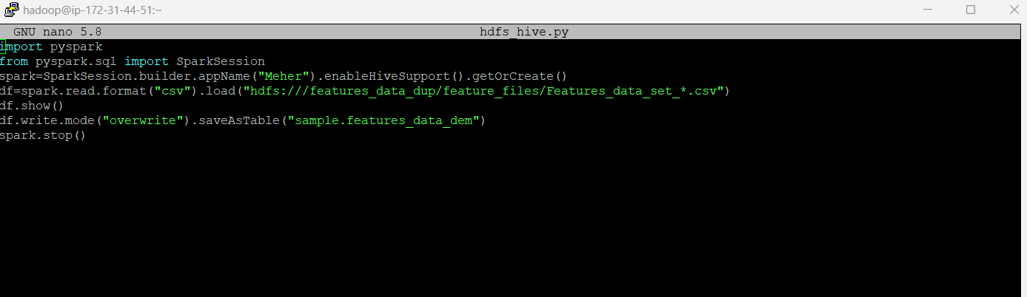

1. Verify whether the data is available in hive in features_data_dem table in /user/warehouse/sample path in hdfs

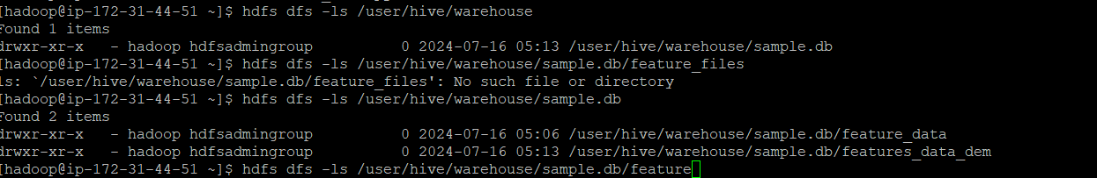

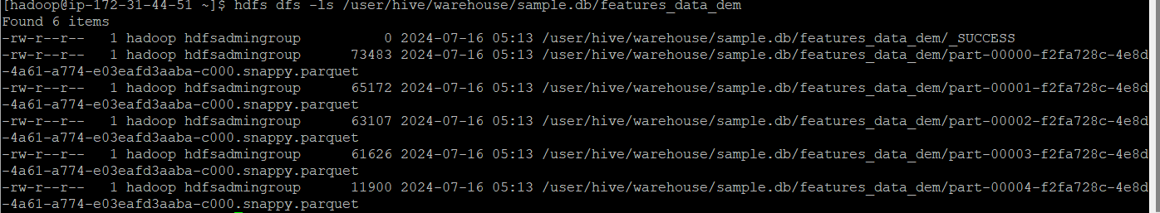

Stage 3:

Push Store Data to AWS RDS

Step 1:

Copy file from s3 bucket



Step 2:

Push to Hdfs

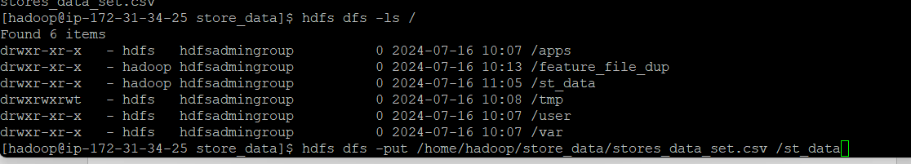

Step 3:

Push the content to RDS using pyspark

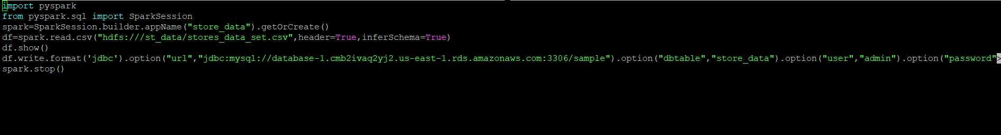

Check whether data is inserted or not in RDS Mysql

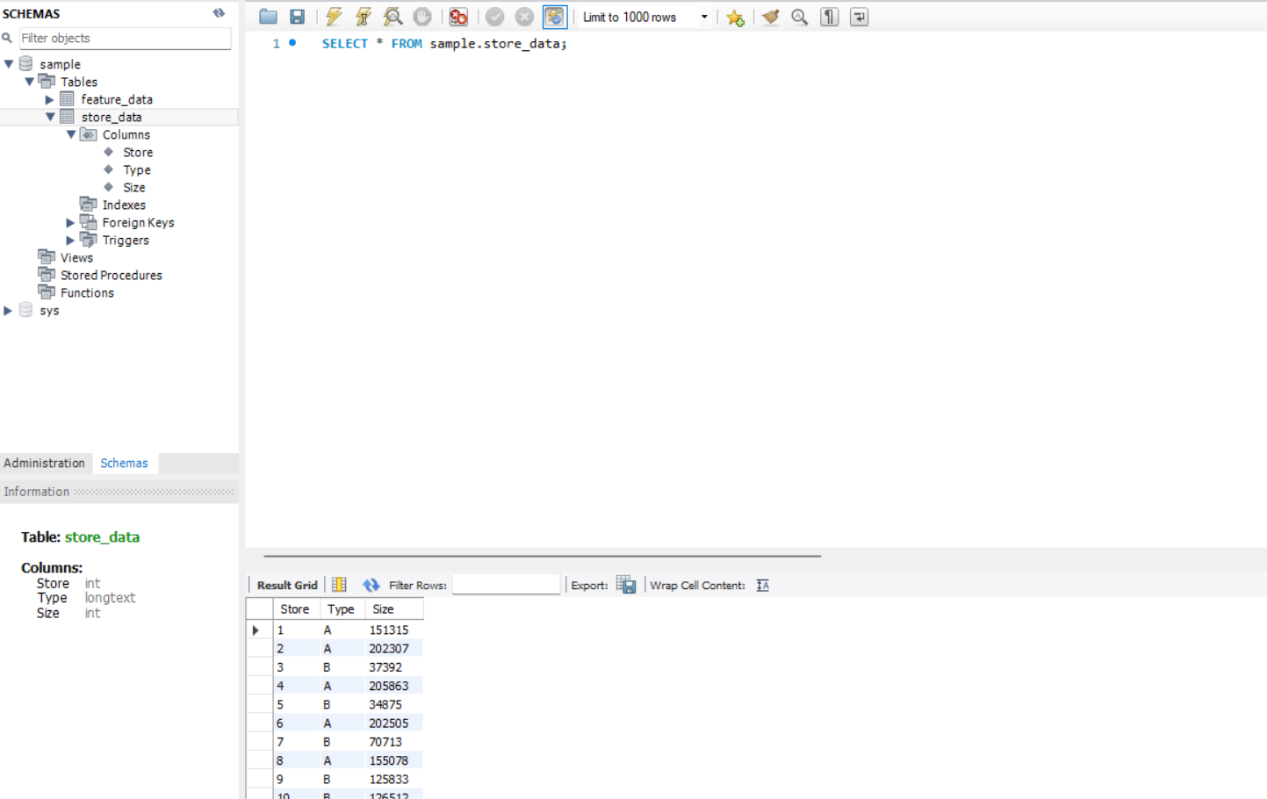

Push rds data to hive using sqoop



Result:

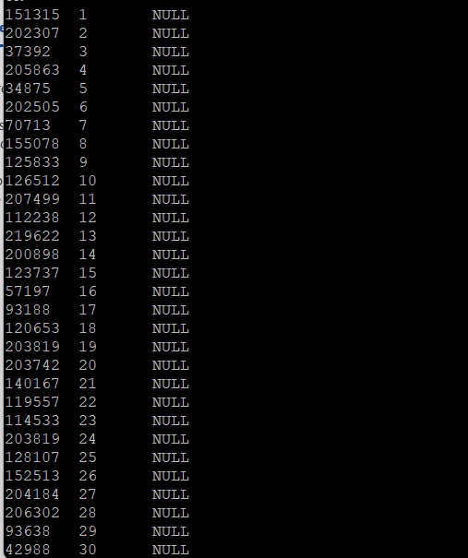

Stage 4

Pushing feature_data from hdfs to rds using pyspark

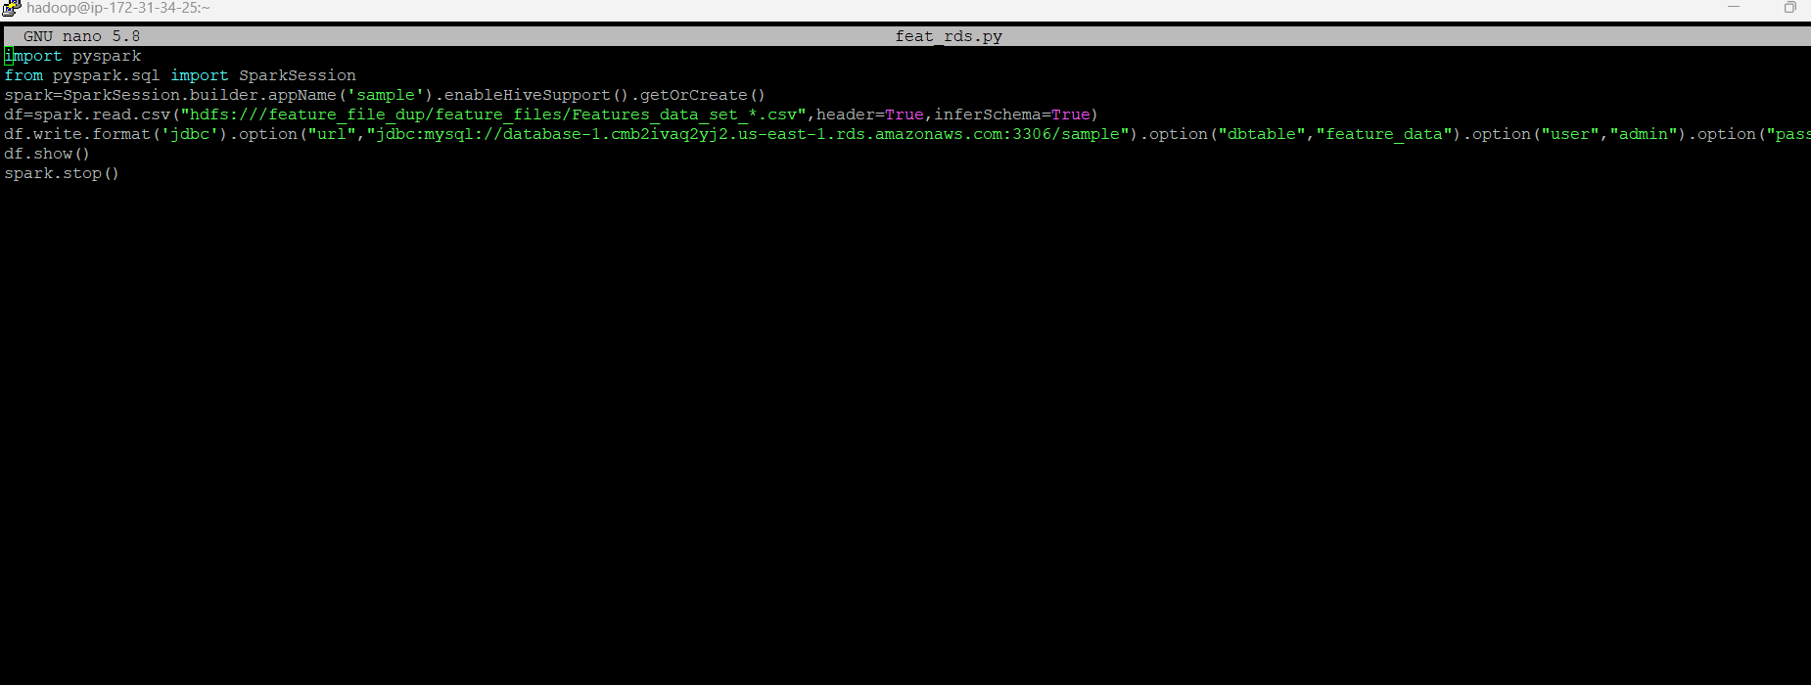

Verify the data in mysql rds

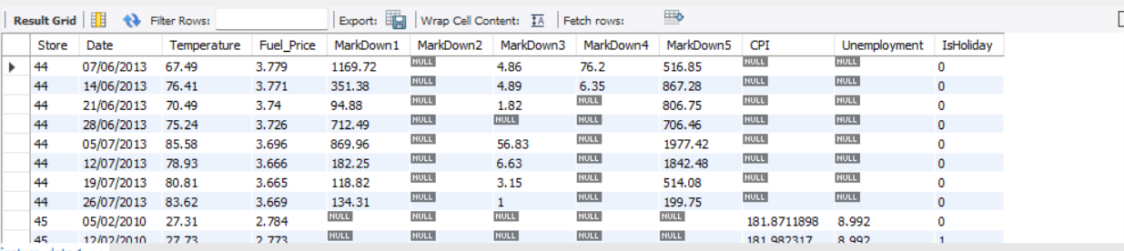

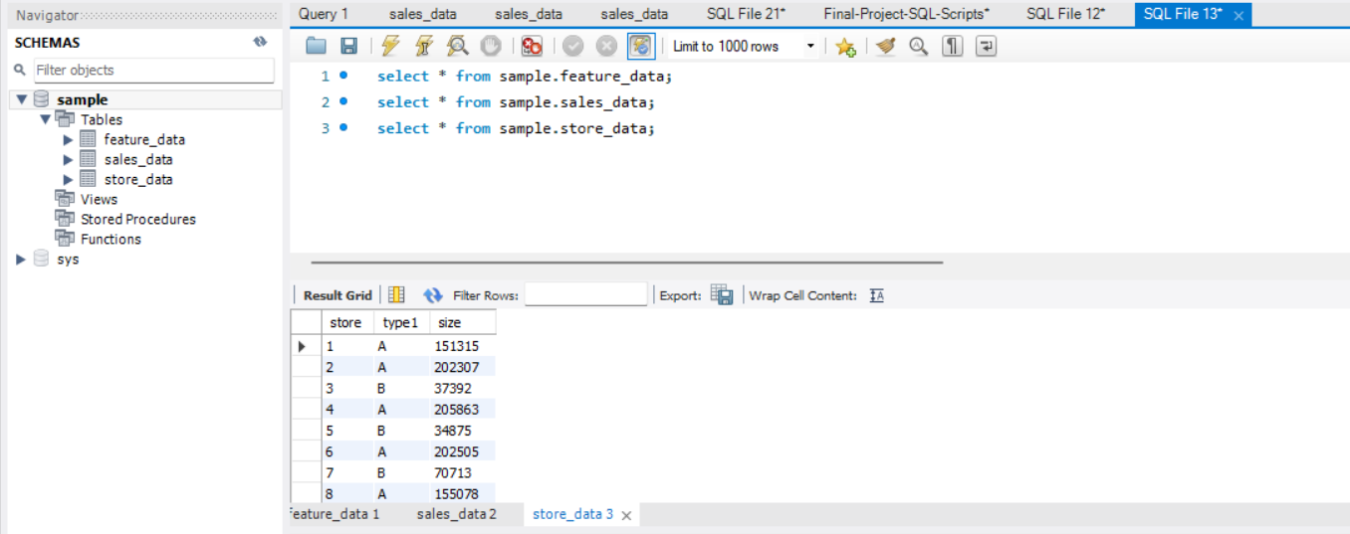

Stage 6:

Monitoring using airflow

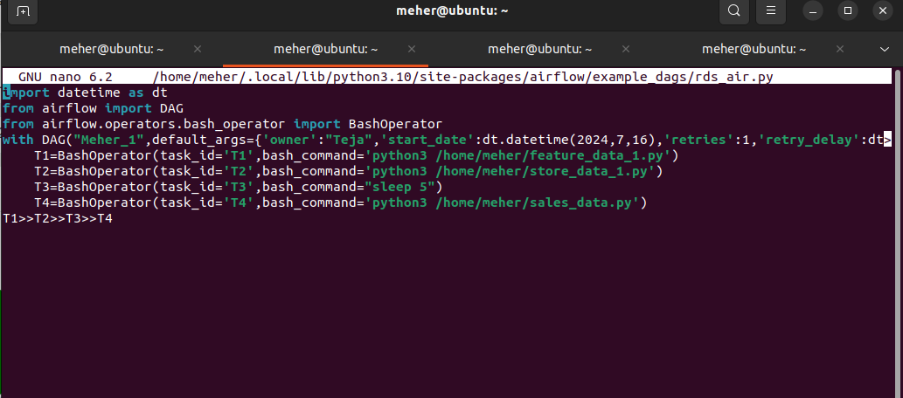

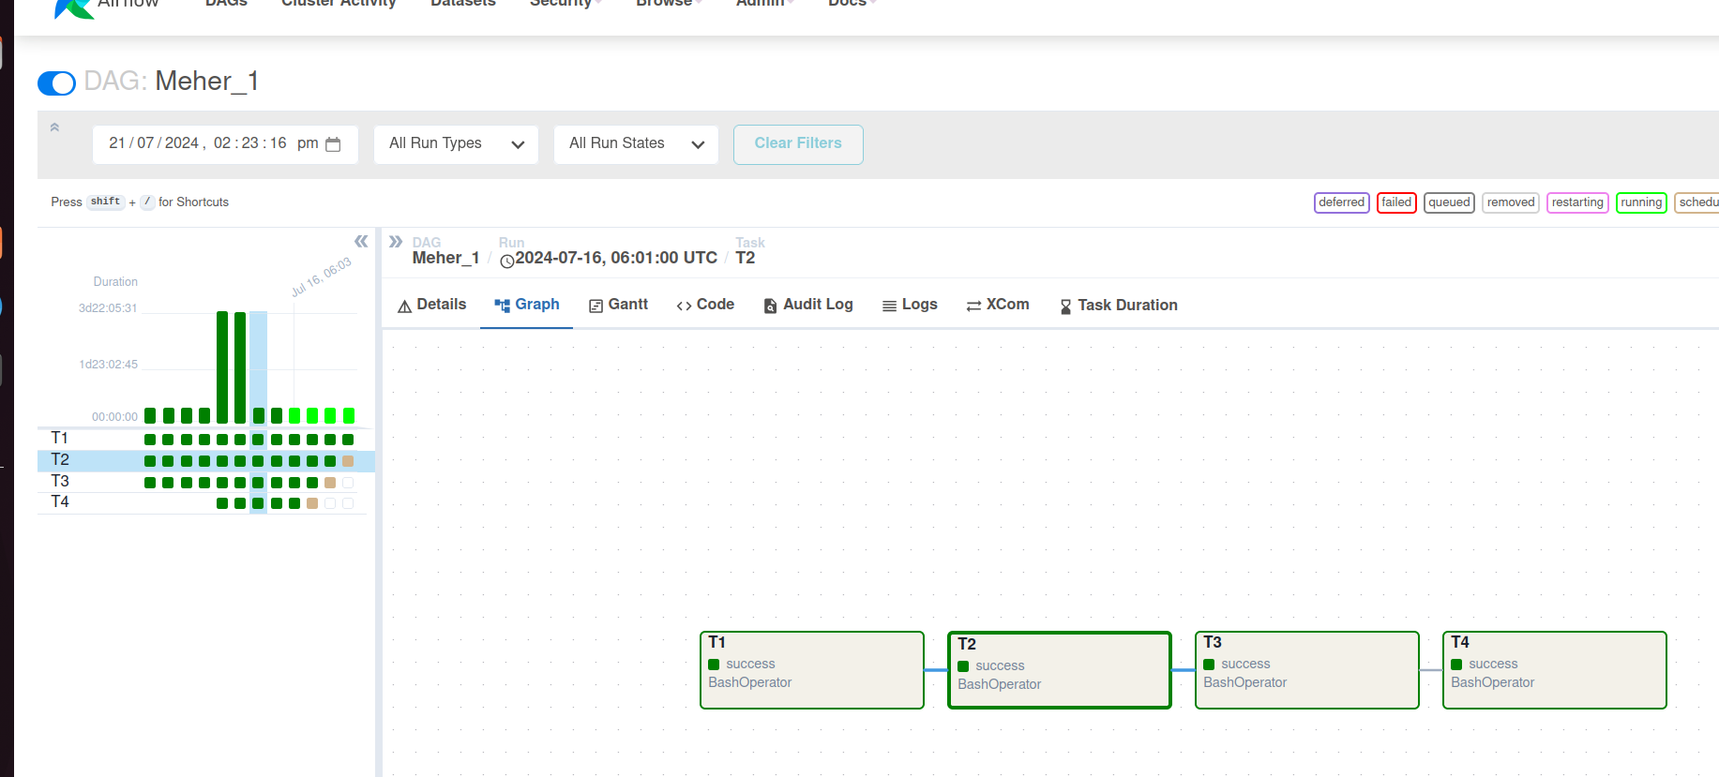

DB Queries

**#Query 1:**

**# Identify average customer visit in the type B store in April Months**

**Query**:

select sum(sd1.weekly_sales)/fd1.cpi as avg_cust_visit from sample.sales_data sd1 inner join sample.feature_data fd1 on sd1.store=fd1.store

inner join sample.store_data std1 on fd1.store=std1.store where std1.type1='B' and Month(fd1.date1)=04;

**Output Snap**

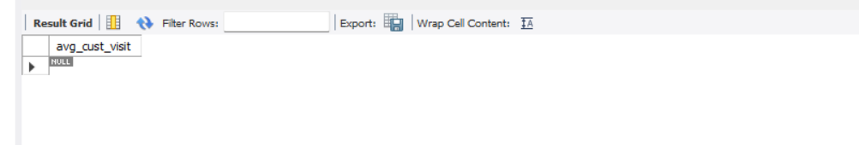

#Query 2:

# Best sales in holiday week for all store types

**Query**:

select max(sald1.weekly_sales) as best_sales,sald1.store from sample.sales_data sald1 inner join sample.store_data sd1 on sald1.store=sd1.store

where sald1.isholiday=1

group by sald1.store;

**Snap**:

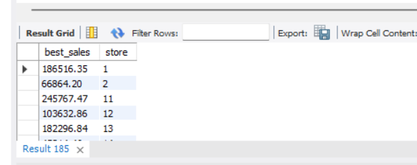

#Query 3:

# Store with worst sales in leap year

**Query:**

select min(sd1.weekly_sales) as worst_sales,sd1.store from sample.sales_data sd1 left join sample.feature_data sfd1 on sfd1.store=sd1.store where ((sfd1.date1%4=1 or sfd1.date1%400=1) and sfd1.date1%100!=1);

**Snap**:

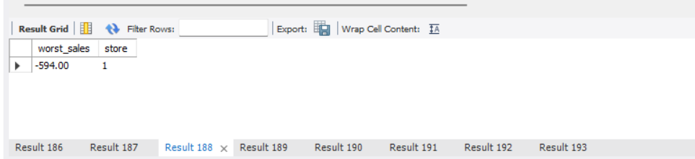

#Query 4:

# What is the expected sales of each department when unemployment factor is greater >8

**Query**:

select (sum(sd1.weekly_sales)+sum(fd1.markdown1)+sum(fd1.markdown2)+sum(fd1.markdown3)+sum(fd1.markdown4)+sum(fd1.markdown5)) as exp_sales from sample.sales_data sd1 inner join sample.feature_data fd1 on sd1.store=fd1.store where fd1.unemployment>8;

**Snap**:

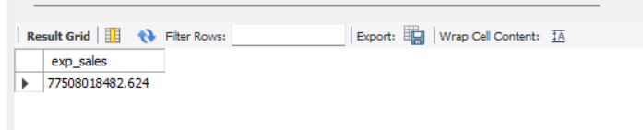

# Query 5:

#Total sales of each department month wise

**Query:**

select sum(weekly_sales) as total_sales_of_dept,dept from sample.sales_data sd group by sd.dept;

**Snap**:

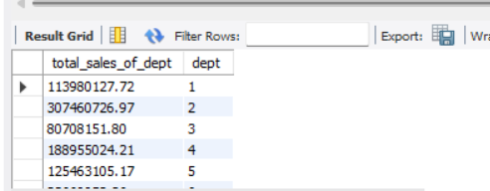

# Query 6

#store with high sales in week wise

Query:

select max(weekly_sales) as high_sales,store from sample.sales_data group by store;

**snap**:

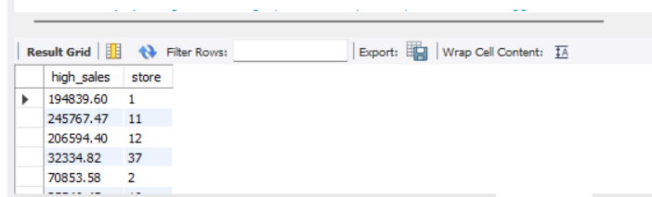

#Query 7

#better dept based performance on the store on all the week

**Query**:

select store,dept,max(weekly_sales) from sample.sales_data group by dept;

**Snap**:

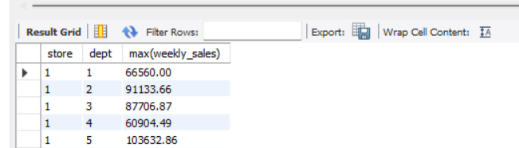

#Query 8

#Identify the store which has minimum fuel price based on the week

**Query:**

select store, date1,min(fuel_price) as min_fuel_price from sample.feature_data group by date1;

**Snap:**

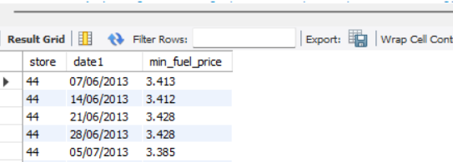

#Query 9

#overall performance of the store based on year wise

**Query**:

select sd1.store,sum(sd1.weekly_sales) as performance from sample.sales_data sd1 inner join sample.feature_data fd1 on sd1.store=fd1.store group by sd1.date1;

**Snap**

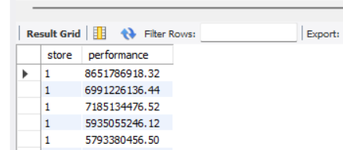

# Query 10

#Find performance of the store where there are no offers

**Query:**

select sd1.store,sum(sd1.weekly_sales) as performance from sample.sales_data sd1 inner join sample.feature_data fd1 on sd1.store=fd1.store where fd1.markdown1 is NULL and fd1.markdown2 is Null and fd1.markdown3 is Null and fd1.markdown4 is null and fd1.markdown5 is Null;

**Snap**

